The following code is a C implementation of a Merkle Tree Abstract Data Type which replicates the functionality/data structure in the bitcoin source code. This is my own implementation where the only information used from sources are the fundamental mechanics of the code from Source: http://www.righto.com/2014/02/bitcoin-mining-hard-way-algorithms.html. The main difference between the code in the source above and in my own is that the one above uses a single array and no tree ADT, my code creates an binary tree ADT allowing you to pass it around as a variable and executing methods on it.
High level overview of the code:
Essentailly the code below creates a Binary tree ADT, the only difference is that rather than an integer stored in each node, an unsigned char array is stored in each node. This array holds a hash. What contraries my implementaion of a Binary tree ADT is that when creating the tree, it starts from the leaf nodes and works its way up until the root of the tree. This is unlike a normal binary tree where it grows fom the root downward. This was necessary when creating a merkle tree as each parent node contains a hash of the concatination of the hashes of its descendants. This is accomplished via putting a pointer to each leaf node in an array and passing this through a recursive function. The recursive function would then concatinate adjacent node hashes, hash them and create a parent node which would point to these previous nodes. A smaller array containing the newly formed parents will be generated and passed on to the recursive function in order to form the next level in the binary tree. This recursive function executes until the array only contains one hash, the merkle root hash. The hashing portion of the code: static void hash(BYTE *a1, BYTE *a2, BYTE *finalHash); takes two adjacent hashes put them into little-endian format, concatinates, hashes them twice, then it puts it back into big endian form.

TEST 1: 4 transactions
To test my Merkle Tree ADT, I used block #100000, this block had 4 transactions which are:

"8c14f0db3df150123e6f3dbbf30f8b955a8249b62ac1d1ff16284aefa3d06d87",
"fff2525b8931402dd09222c50775608f75787bd2b87e56995a7bdd30f79702c4",
"6359f0868171b1d194cbee1af2f16ea598ae8fad666d9b012c8ed2b79a236ec4",
"e9a66845e05d5abc0ad04ec80f774a7e585c6e8db975962d069a522137b80c1d"

and a merkle root hash of f3e94742aca4b5ef85488dc37c06c3282295ffec960994b2c0d5ac2a25a95766
website: https://blockexplorer.com/block/000000000003ba27aa200b1cecaad478d2b00432346c3f1f3986da1afd33e506

I received the same merkle root
TEST 2: 2 transactions
I also tested with a block with only two transactions: BLOCK #100017
Transactions:
efcf836ce9ff2d5742bfd0e9b6ef6a8e97b8d78f869059b63ba9ef938b8b19e0
42e9c04febf5cb837e1dcf0e5023036fbcb8cd2a07c8f91acb89b09085dfe9ed
Resulting hash was:
7827dc9a6303cfb0507abd954709790837256960ca28eb99336001d6d6822a7a

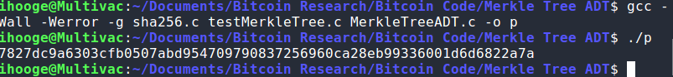
https://blockexplorer.com/block/000000000000188cc1d8c256e867dc0a65d778896485559e9ed80879e51d894d

TEST 3: with one transaction
Testing with a block of only one transaction (the coinbase transaction hash becomes the merkle hash, no tree is formed): BLOCK #100045
transaction: 41a731c408dea42ce5fe60c44024b99cd116f6b2dee4a37e5fce8b878f654f75
https://blockexplorer.com/block/0000000000008bcabf41b85a256e0b372c70fe0bb5179011c3e4ac43ce97a2d3

Test 4: with 3 transactions
Block #101059, transactions:
e48755f4fee69c5f5039b19e2242bd3d3cbaf2f9322c3cf018a95a9c111c24ce
a2343f90cfe9b6d839abbb37e08d6e18bfe995ac954bf04ea33fffdb60f51df6
32b5b0300a0bff6940d66d5fea3b2c272bee68e77ea49e0d11e7c4297d8df489
if you compare the merkle root my program calculated in the picture below to that of the merkle root in the below link, you would find that they are the same. This is also the case with all the test cases above.
https://blockexplorer.com/block/0000000000020e3b7bcd4520910b37a7018463ba1a2cb1d6ea7148e663f6eaf8

when generating these tests, I copies each of the transactions hashes side by side in order, I then in the terminal take this string of transactions and using a bash script, parse every byte of hex with “, 0x” as this is the format needed in c.
script:
foo=””
echo $foo | sed 's/\(..\)/\1, 0x/g'
this echos the parsed transactions into the terminal which I then copied into the BYTE string[] = {0x.., 0x…..};, it was also necessary to change the number of transactions used in the function createMerkleRoot(Tree, string, 3); where 3 represents the number of transactions in the string array, this is required when generating a merkle root.
e.g.
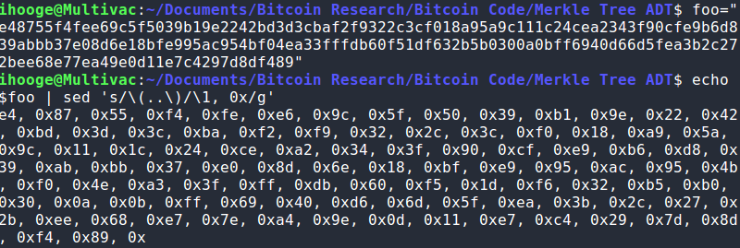
one thing to note is that the first byte does not receive an “0x”, and ther is an extra “, 0x” at the bottom, if you add the “0x” to the first byte and remove the extra last one you then would copy the string and put it in the string variable and modify the number of transactions in the createMerkleRoot function.

